Tara Erickson

November 16, 2021

IT FDN 110 A

Assignment 05

GITHUB Link: <https://github.com/terick9/UWPython-Assignment-05>

**Python To Do List**

**Introduction**

The purpose of this paper is to document the steps I took to complete Assignment 05.

**Assignment 05 modify** **a new script that manages a "ToDoList”**

This assignment asks for a program which asks the user to choose from a menu of options, and respond accordingly utilizing lists and dictionaries. Some basic syntax was provided by the university.

Step 1 – Loaded a list of to-do items into a dictionary. Created a list table from the dictionary items. Wrote the initial data to a file, ToDoList.txt. (Figure 1)

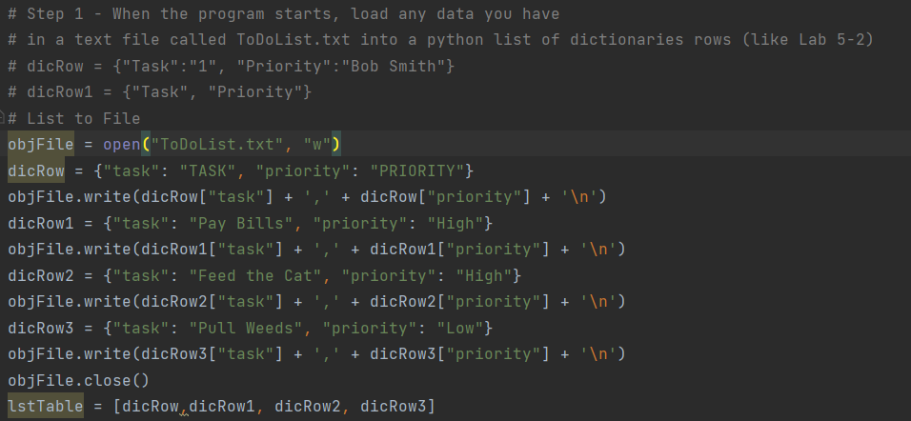

***Figure 1: Script for creating the list table.***

Step 2 – This is the syntax for the menu of choices. This was provided by the university. (Figure 2)

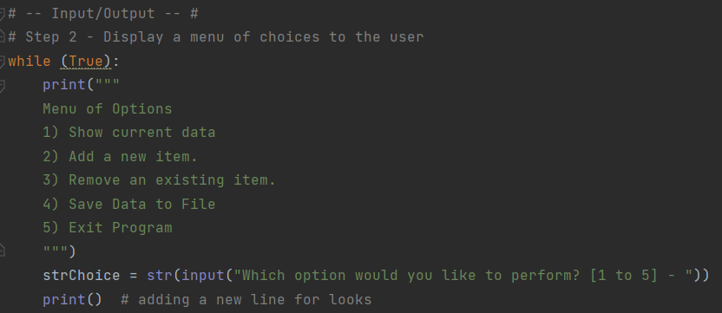

***Figure 2: Menu Choices***

Step 3 – Created a script for menu option 1 to display (or print) the data within the list table. (Figure 3)

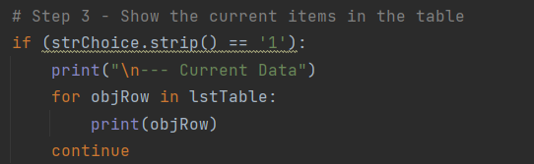

***Figure 3: Option 1 Script***

Step 4 – Created a script for menu option 2 to add a new to-do item to the table. This script has a while loop so that the user can enter multiple items. (Figure 4)

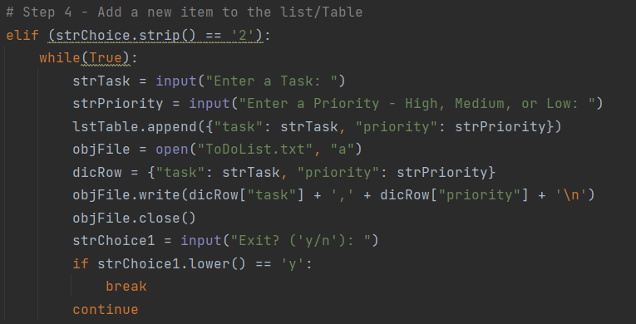

***Figure 4: Option 2 Script***

Step 5 – Created the script for menu option 3, remove a row based on the name of the task. This script loads the data from the text file into memory(read), asks for a user input (task name), and then looks through each row until the task name is found (or not). (Figure 5)

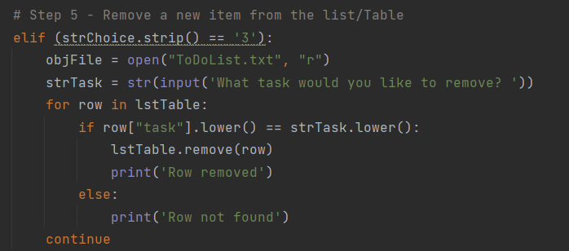

***Figure 5: Option 3 Script***

Step 6 – Created the script for menu option 4, saving the to-do items to a file. (Figure 6)

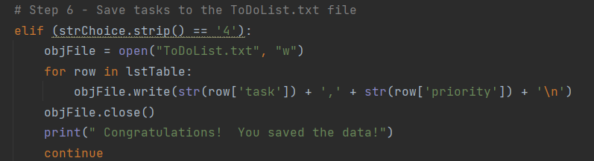***Figure 6: Option 4 Script***

Step 7 – Created the script for menu option 5, to exit the program. (Figure 7)

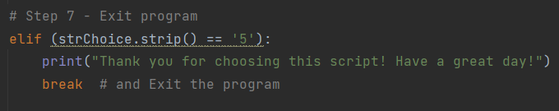

***Figure 7 – Option 5 Script***

Step 8 – Ran the script in a command window. (Figures 8,9,10,11,12)

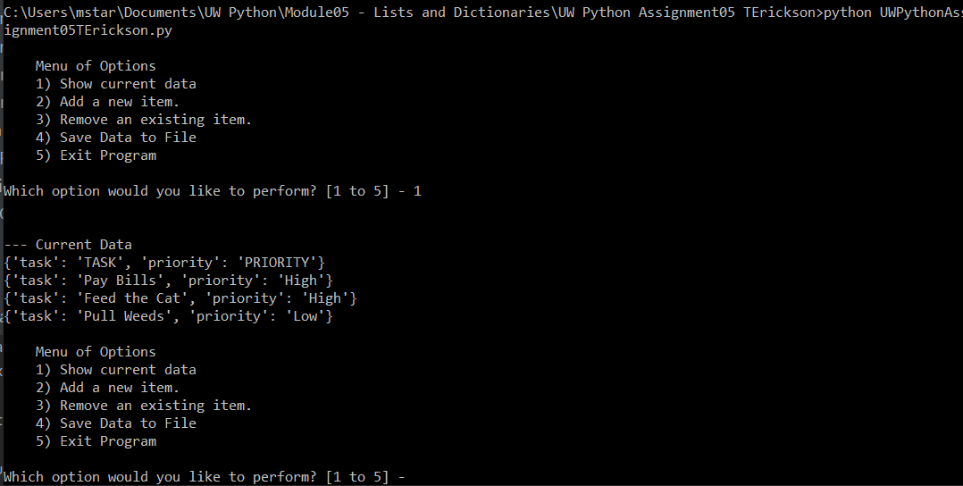***Figure 8: Script running in command window – User Selection 1***

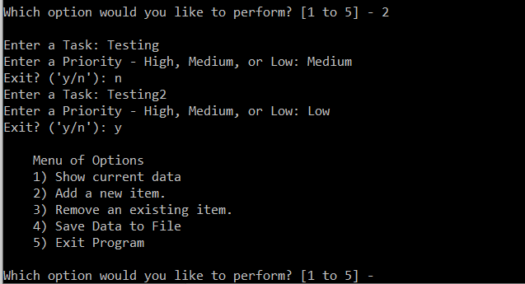

***Figure 9: Script running in command window – User Selection 2***

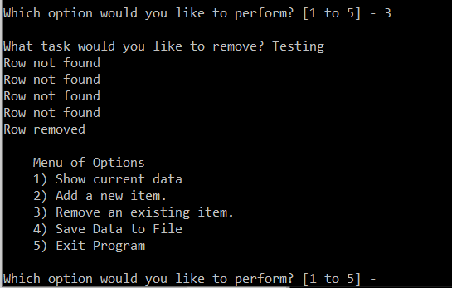

***Figure 10: Script running in command window – User Selection 3***

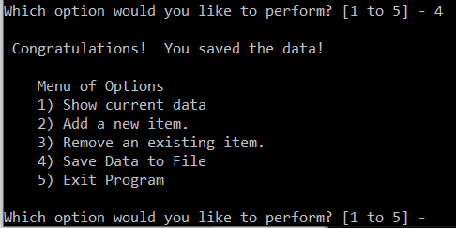

***Figure 11: Script running in command window – User Selection 4***

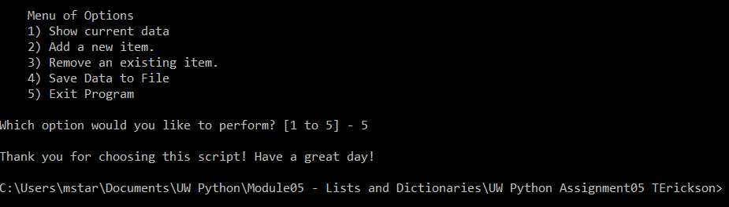

***Figure 12: Script running in command window – User Selection 5***

**Summary**

This paper outlined the steps I took to complete Assignment 05.